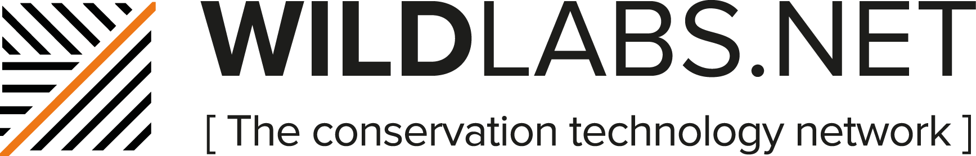

WILDLABS.NET is an online community that connects conservationists and technology experts from around the world to find technology solutions for a wide variety of environmental challenges. This is a space where members can share experiences, explore ongoing projects, and identify major questions and needs. WILDLABS.NET is also a resource for people who want to learn more about technology or conservation and join forward-thinking conversations.

You can find more information about the community in our Community Guidelines and our FAQs. If you have any other questions, get in touch at community@wildlabs.net.

New User Instructions
Join the Community

To join the community, click on ‘Login’ in the top right menu.

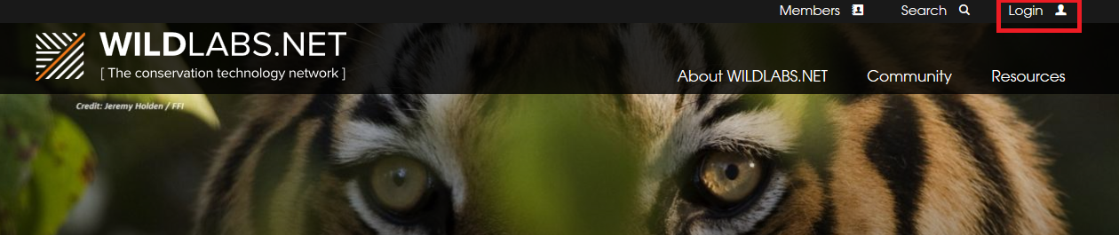

This will take you to the login screen, where you will find an option to ‘Register a new account’
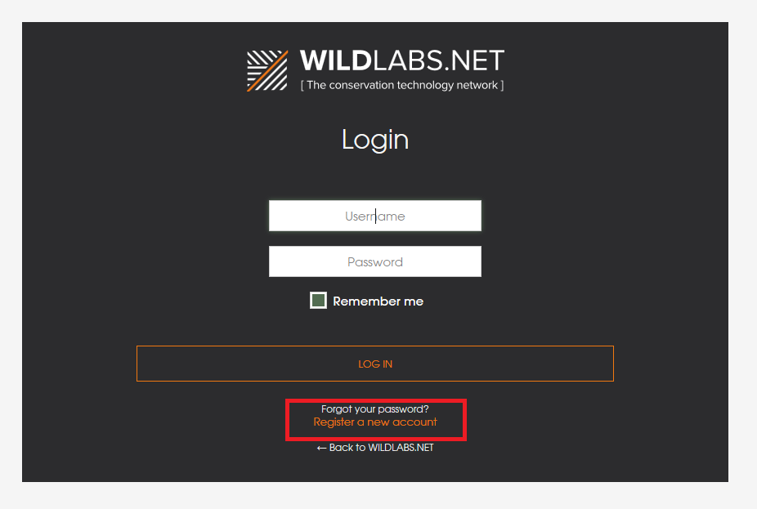
As this is a professional community, we do recommend choosing a user name that is close to your actual name, for example ‘JaneDoe’.

Once you’ve registered your account, you will receive an email with a link to confirm your account. When you click on this link, you’ll be taken to a page to fill out your full profile. As new users, we ask that you do take the time to fill your profile out properly – it shouldn’t take more than a few minutes. You can also select your privacy setting here, opt in or out of appearing in the member directory and change your subscription settings.

Joining Groups

As a logged in member you now have the power to join groups, start conversations and reply to other member threads. Head over the Community and explore the groups that are live already. To ‘join’ a group, all you need to do is to either participate in a conversation – either by starting a thread or replying in a thread that is already live – or by requesting membership on the group homepage:

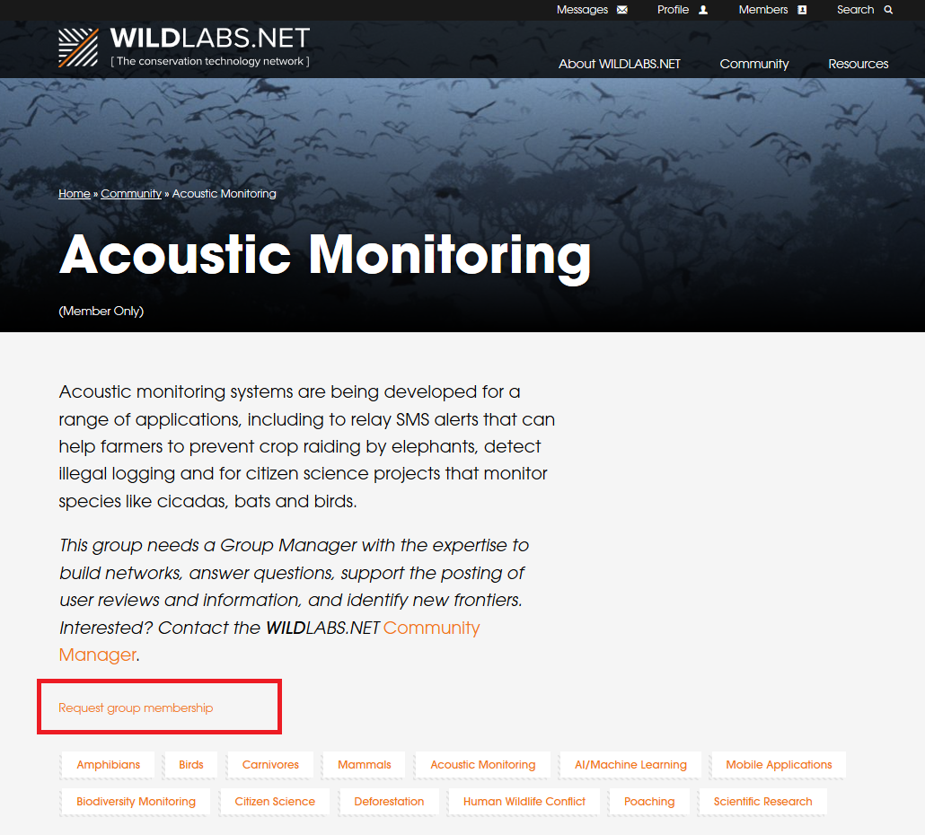

When the group manager approves your membership, you will receive an email alert and the group will appear in your list of subscriptions on the community front page and in your dashboard.

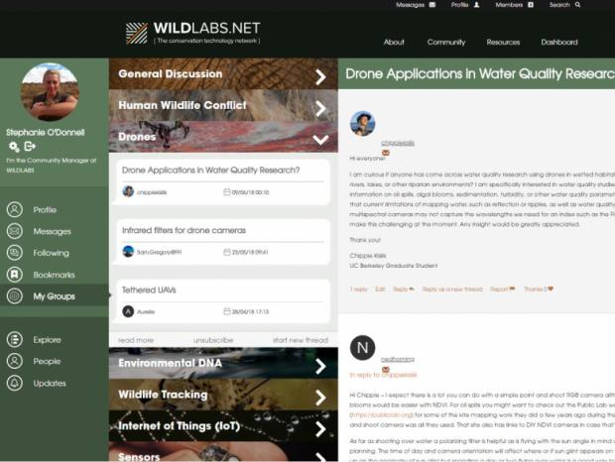
Post a Thread

There are three main ways we see members using the community. These are to:
- Share information to increase transparency and reduce replication of effort
- Ask and answer questions to share best practice, to increase efficiency and effectiveness of technology deployment to address conservation challenges
- Collaborate to improve existing technologies or develop new technologies that address identified conservation needs.
More specifically, you could start a thread to:
- Posting questions you are having in your work
- Starting a thread about a project you are working on, and posting regular updates as it progresses
- Posting newly released articles, papers, news items and announcements that might be of interest to other members
- Asking members to help collate project lists, or links to open access data and schematics
- Instigating discussion around a contentious issue in your field
- Starting a thread to elicit field user reviews of a specific tech or product

Create a thread: From your Dashboard
To start a thread from your dashboard (if you are already a member of the group), 1) Go to the groups menu, 2) Click the group name to open up the group you want, 3) Click ‘Start New Thread’ and fill out the information.
Create a thread: From the Community
To start a thread from the community page, go into the group where you want to start the group and click the ‘New Thread’ button
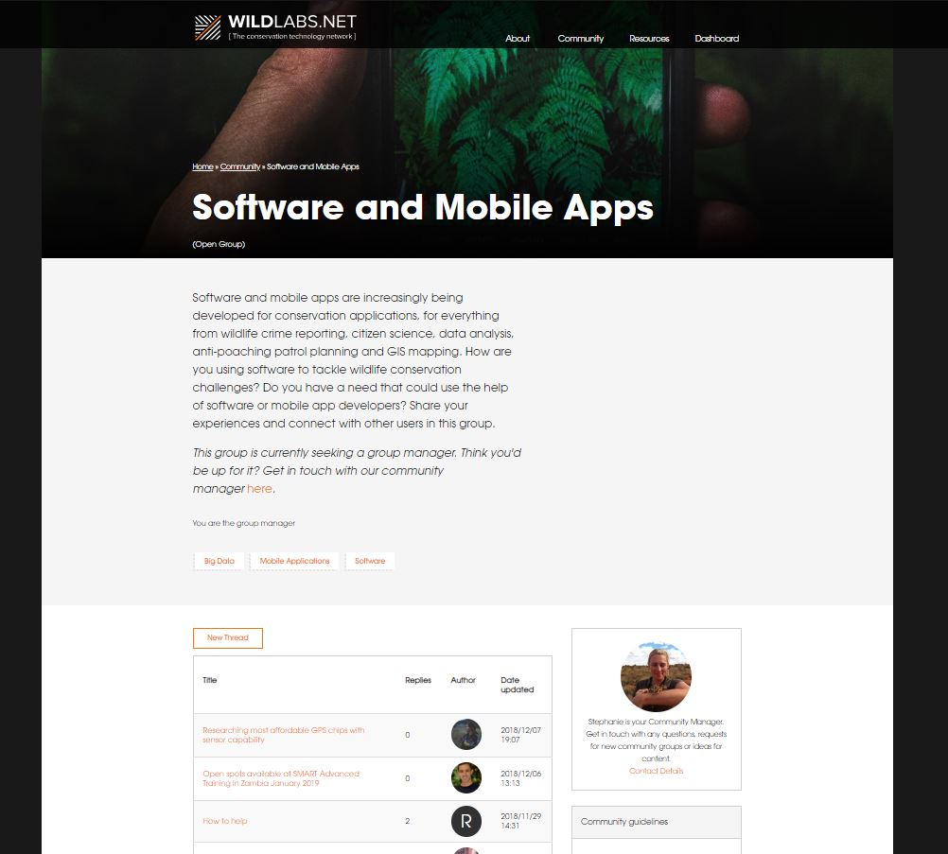

Create New Thread page
Both routes will take you to the following screen.
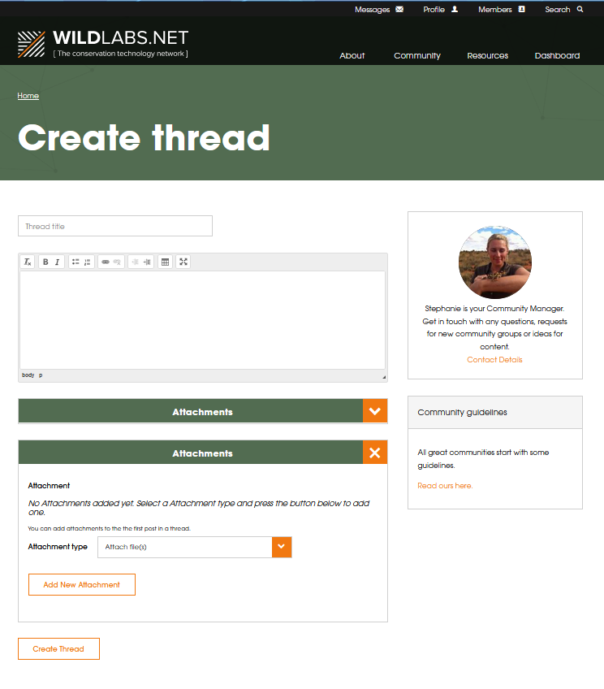
- Choose a Title for your thread - make it short and descriptive. Think about key words that will get the people you need to take a look at your question/discussion.

- Fill out the text box with your post – the more detail the better! We find members who include more information get the best response.

- Attach any images, files, links to the post using the attachment box

- Click ‘Create Thread’ – it will now appear in the group you selected. You can edit the post by clicking ‘edit’ in the menu at the bottom of your first post.

- You’ll get email alerts (if you’ve opted in) in anyone posts a reply. Your thread will also appear in your dashboard under the ‘Following’ tab

We’re also keen to hear from people interested in becoming group managers – see our FAQs for more information. Finally, we want to hear any ideas you have for the site. What do you want – resources, case studies, thought pieces, and functionality? Please get in touch at community@wildlabs.net.

